Assignment 4: Colorization

# Group Members

* **Harshil Patel:** Improved Agent + Questions
* **Mehul Patel:** Preprocessing + Documentation + Helper Functions + Questions
* **Jonathan Pinto:** k-means **+** Basic Agent + Questions

# Notes about Project

# Questions and Writeup

## The Basic Agent

How good is the final result? How could you measure the quality of the final result? Is it numerically satisfying, if not visually?

* The final result for K-means was very good. K-means worked really well and found good representative colors within 10 iterations despite the number of centroids. If you look at graphs from 12 - 17 and the associated image, the colors look representative of the image itself.
* The final result for the other part of the basic agent was alright. In terms of finding the correct centroid, it did well. If you look at graphs 1 - 11, you can see the results of recoloring with and without using weights while using either 5, 10, 20, or 30 centroids. The accuracy and loss that you see is calculating if the basic agent picked the wrong centroid. So for example, if it picked a green centroid over a red centroid, the loss would be calculated as the distance from the green centroid to the red centroid. Note, this loss is not the Euclidean distance, but rather, the Manhattan distance. The accuracy was calculated by taking the subtracting the loss by 768 (768 because 256*3 pixels in total) and then dividing by 768 again. Therefore, that is why the accuracy is very high, since the difference between the centroids were often not too large on average.
* On the other hand, if you simply look at the accuracy between the real color value and the predicted color, the accuracy is quite bad. **This is the accuracy that was used when calculating the accuracy for the improved agent**. When looking at the normal accuracy, it is any where between 65% and 80%. As I increased the number of centroids, although it looked better, the accuracy was decreasing. Therefore, I concluded that this was not a good estimate to tell if the result looked “good”.

Bonus

Instead of doing a 5-nearest neighbor based color selection, what is the best number of representative colors to pick for your data? How did you arrive at that number? Justify yourself and be thorough.

* The best number of neighbors is really depended on the picture. For the first picture, 10-15 centroids was fine. However, for the second image, 15-20 centroids fit better. Also, I justify these numbers by looking at the accuracy and the way it looks. As you can see in the graphs, graph 3 and 4 with 10 centroids have the best accuracy and it also looks pretty great. Also, for the second image, graph 11 with 20 centroids has the best accuracy and looks the best. Therefore, the best number of colors to pick heavily depends on the picture and how many unique colors the picture has and the range of the RGB values.

The Improved Agent

Figures

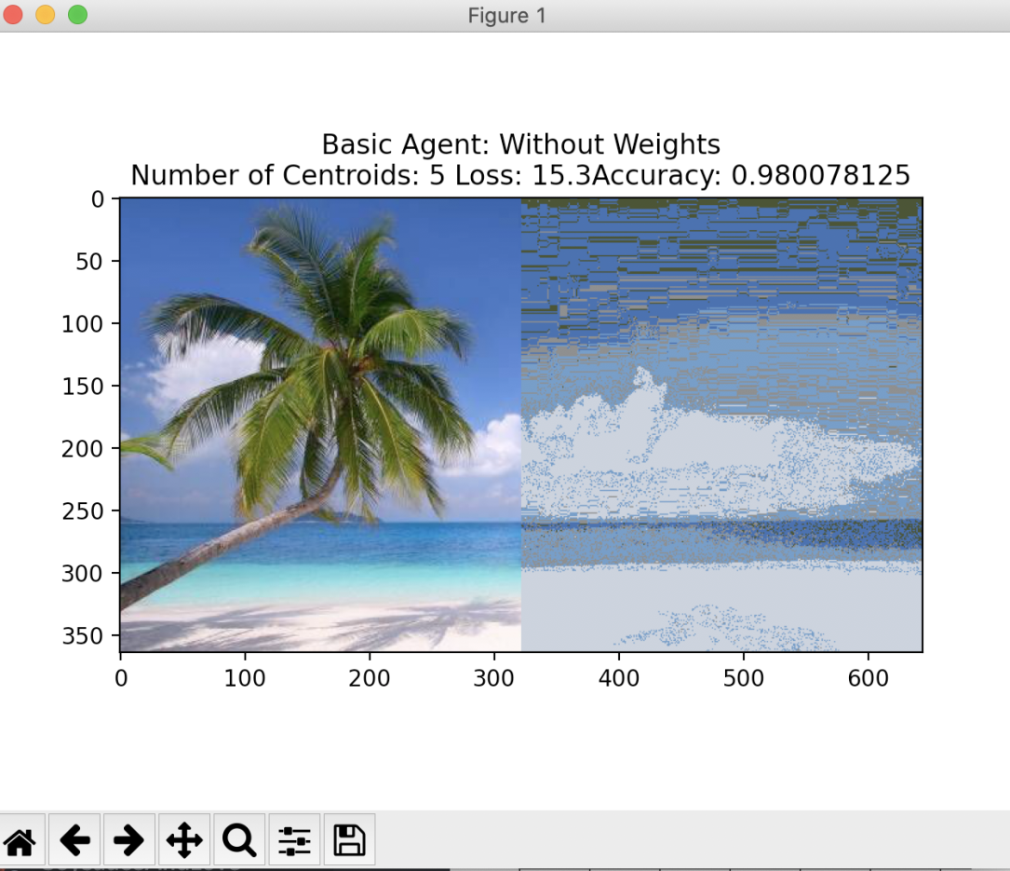

Graph 1 Basic Agent without weights with 5 centroids

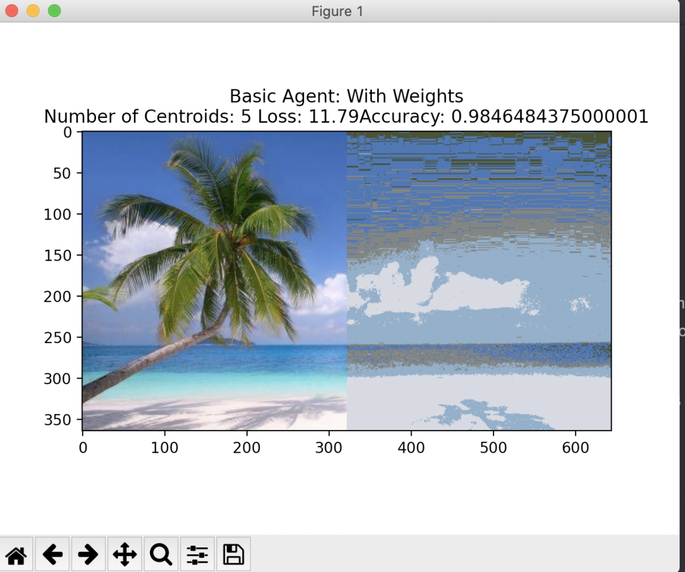

Graph 2 Basic Agent with weights with 5 centroids

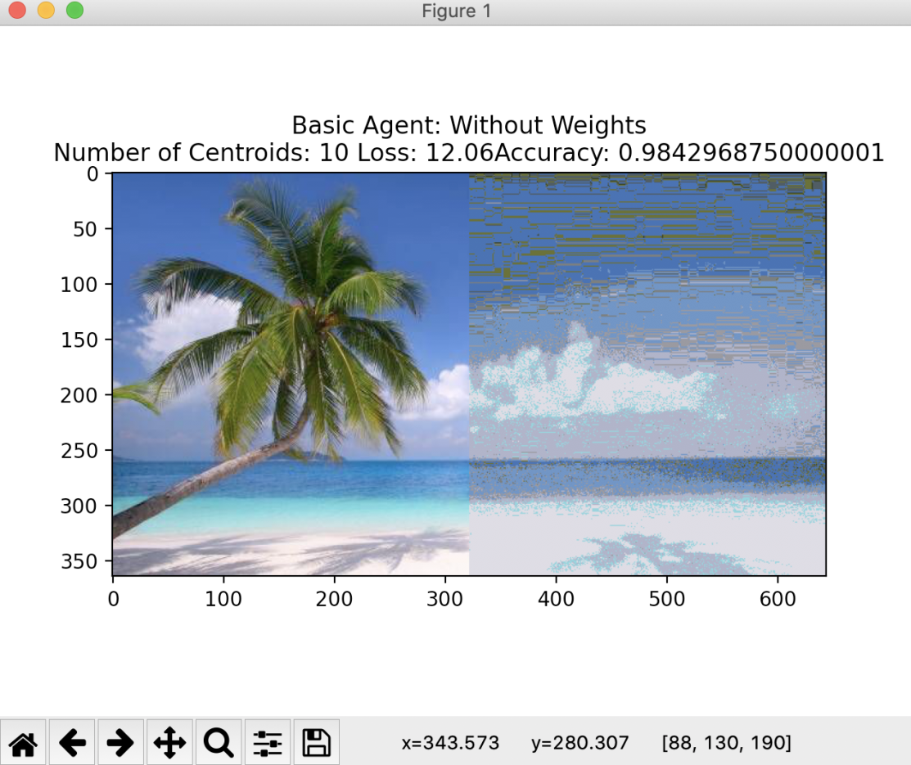

Graph 3 Basic Agent without weights with 10 centroids

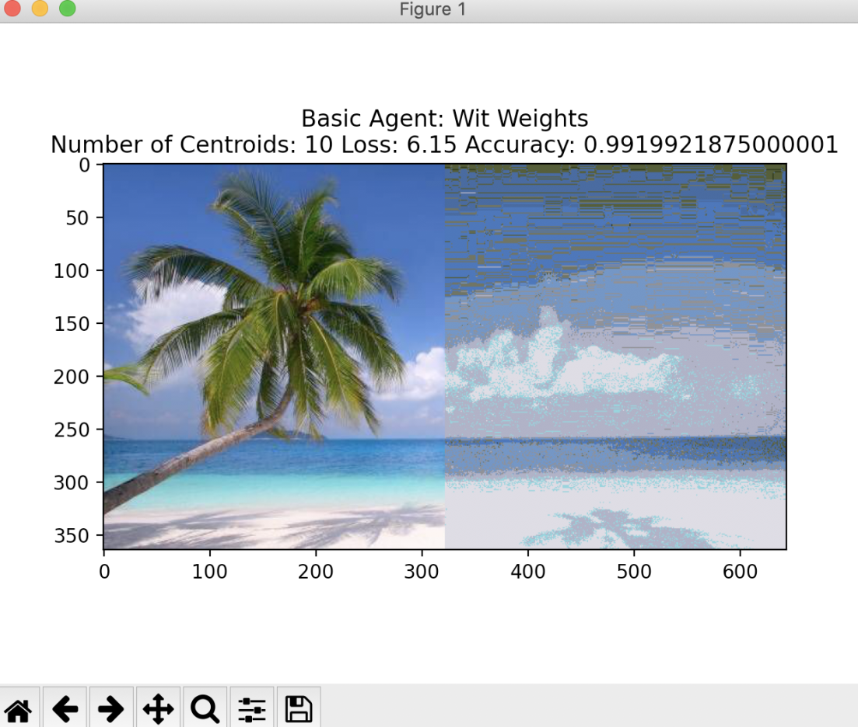

Graph 4 Basic Agent with weights with 10 centroids

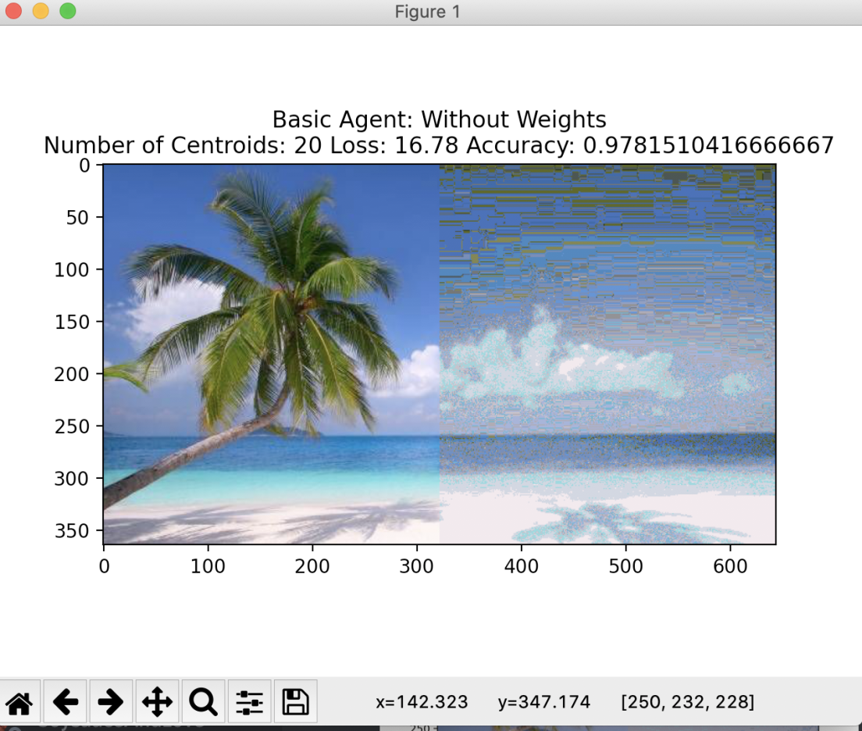

Graph 5 Basic Agent without weights with 20 centroids

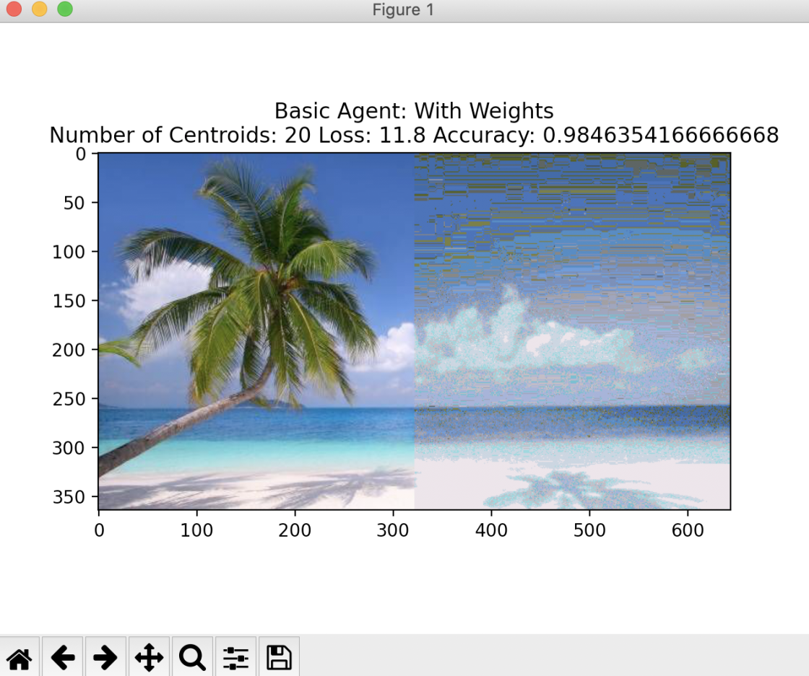

Graph 6 Basic Agent with weights with 20 centroids

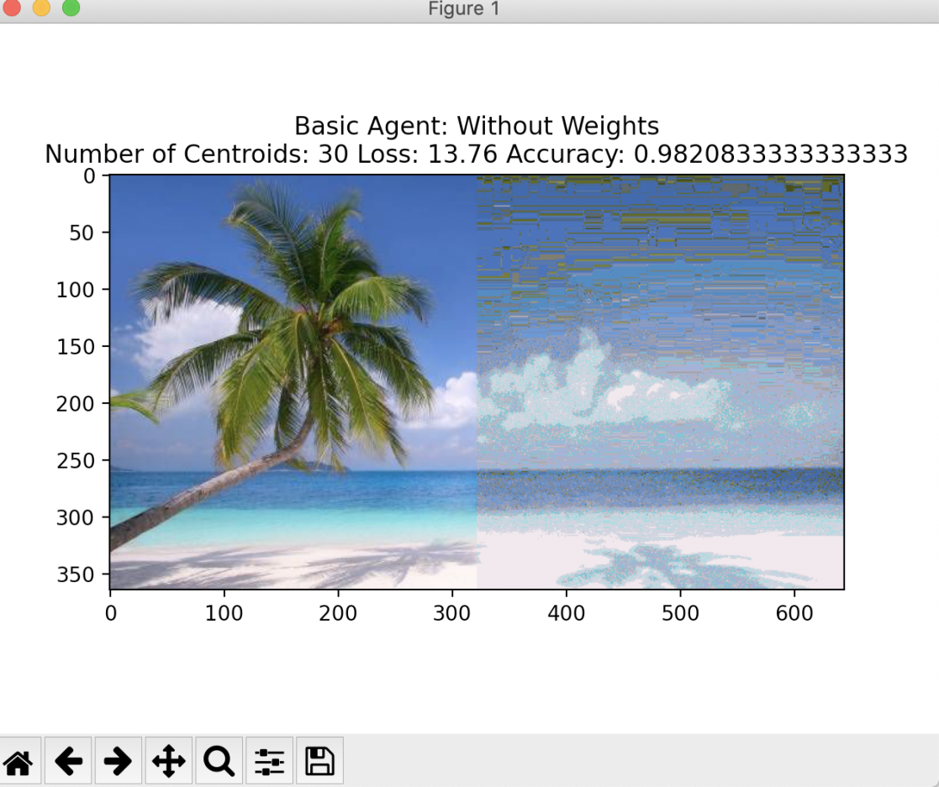

Graph 7 Basic Agent without weights with 30 centroids

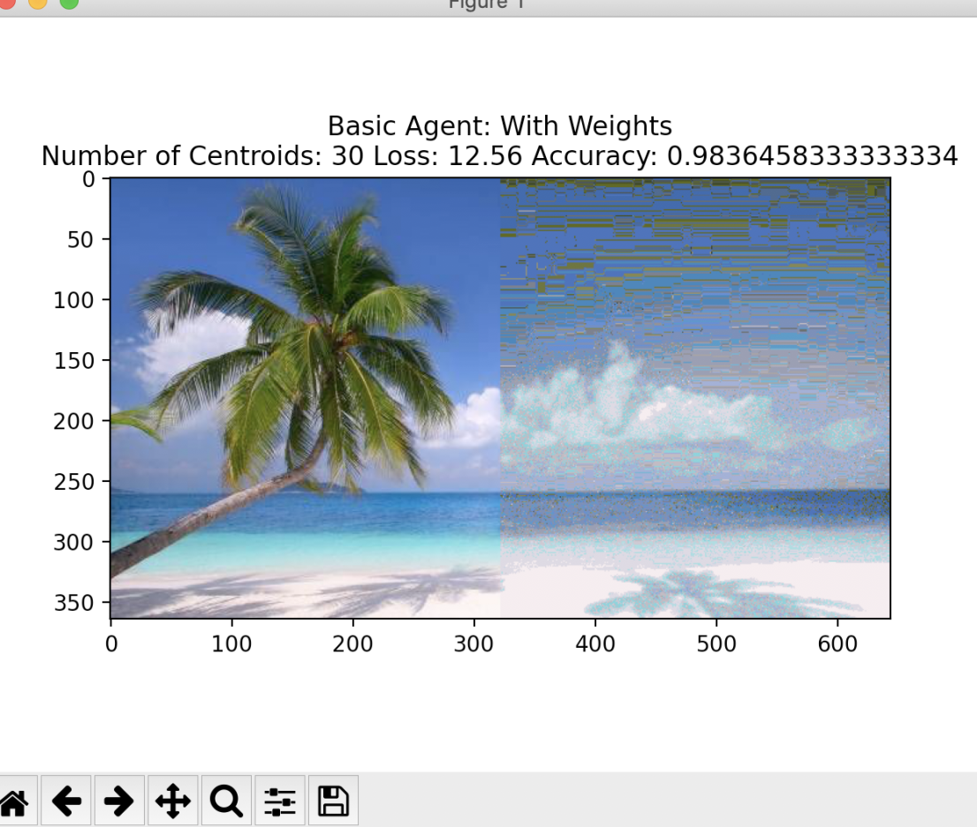

Graph 8 Basic Agent with weights with 30 centroids

Graph 9: Basic Agent with weights wit 5 centroids: Image 2



Graph 10: Basic Agent with weights wit 10 centroids: Image 2



Graph 11: Basic Agent with weights wit 20 centroids: Image 2

Graph 12: K-means 5 centroids: Image 1

Graph 13: K-means 10 centroids: Image 1

Graph 14: K-means 20 centroids: Image 1

Graph 15: K-means 5 centroids: Image 2

Graph 16: K-means 10 centroids: Image 2

Graph 17: K-means 20 centroids: Image 2

